**CSC/ECE 573: Homework 2 Report**

**Name and unity IDs of group members**

***Remove the plots and all the text in red, including this sentence.***

**Packet Sniffer**

**Plot of packet counts:**

Plot the results of three experiments as shown below. You can make this plot in excel.

* x-axis has different protocol for which you are counting packets
* y-axis has the number of packets
* Different color lines are for different experiments
* ***The plot below is for example. It does not show actual experiment values.***

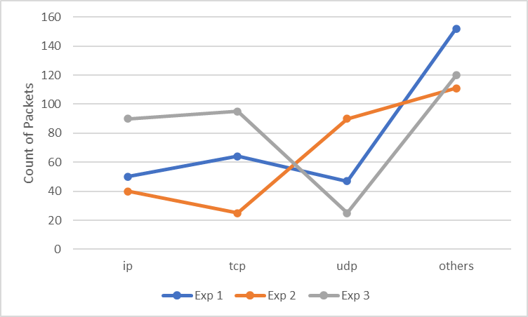

**Analysis:**

Discuss the results obtained and give your observations. For example: why certain experiment has large number of packets for one protocol and less for the other? How does one experiment compare with the other? etc. Think about the results and give your thoughts. Be precise and to the point.